Title  Insert your photo here  675 pixels wide x  800 pixels height  resolution: 72 -250 ppi  the photo must be clear at  100%-150% screen view.  Photo file size must be  150-250kb in size | 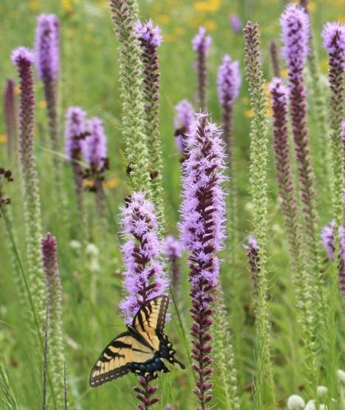
 | 2 | Genus species  FAMILY  Common Name  XX | 3 | Genus species  FAMILY  Common Name  XX | 4 | Genus species  FAMILY  Common Name  XX
Title

 | 2 | Genus species  FAMILY  Common Name  XX | 3 | Genus species  FAMILY  Common Name  XX | 4 | Genus species  FAMILY  Common Name  XX

Title

 | 2 | Genus species  FAMILY  Common Name  XX | 3 | Genus species  FAMILY  Common Name  XX | 4 | Genus species  FAMILY  Common Name  XX
Title

 | 2 | Genus species  FAMILY  Common Name  XX | 3 | Genus species  FAMILY  Common Name  XX | 4 | Genus species  FAMILY  Common Name  XX

Title

 | 2 | Genus species  FAMILY  Common Name  XX | 3 | Genus species  FAMILY  Common Name  XX | 4 | Genus species  FAMILY  Common Name  XX
Title

 | 2 | Genus species  FAMILY  Common Name  XX | 3 | Genus species  FAMILY  Common Name  XX | 4 | Genus species  FAMILY  Common Name  XX

