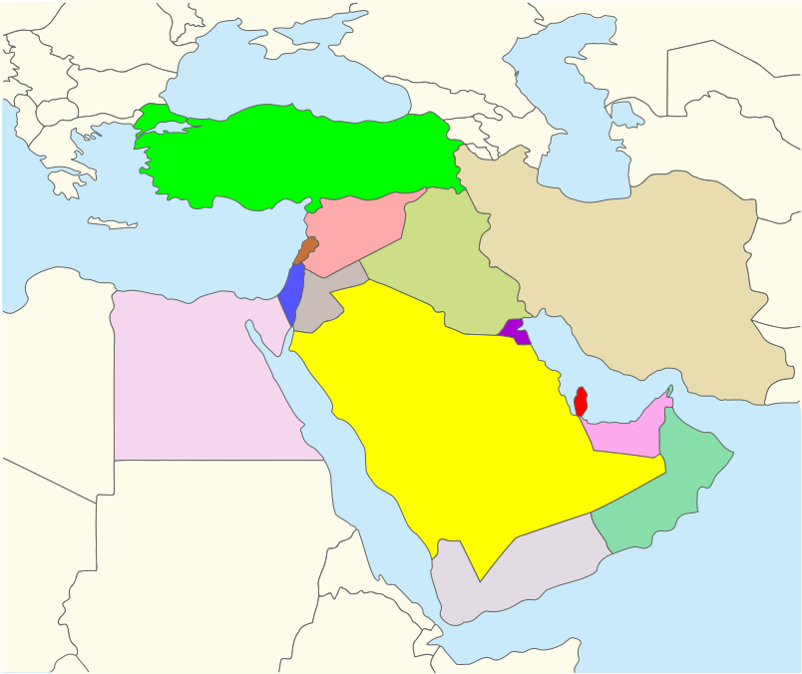
Lorem Ipsum is simply dummy text of the printing and typesetting industry. Lorem Ipsum has been the industry's standard dummy text ever since the 1500s, when an unknown printer took a galley of type and scrambled it to make a type specimen book. It has survived not only five centuries, but also the leap into electronic typesetting, remaining essentially unchanged. It was popularised in the 1960s with the release of Letraset sheets containing Lorem Ipsum passages, and more recently with desktop publishing
Resolution for Map: 150-200ppi
Insert your photo here  400 pixels wide x 600 pixels height  Resolution: 72 -250 ppi  the photo must be clear at  100%-150% screen view.  Photo file size must be  150-250kb in size  If applicable, Quality should be 8-10 |  |  | 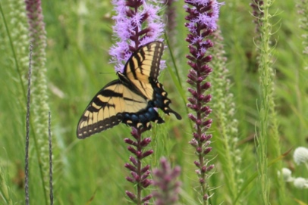 |  |  | 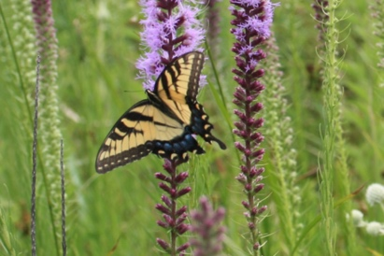
1 | Genus species  FAMILY  Common Name  XX |  | 2 | Genus species  FAMILY  Common Name  XX |  | 3 |  | Genus species  FAMILY  Common Name  XX | 4 | Genus species  FAMILY  Common Name  XX
5 |  | Genus species  FAMILY  Common Name  XX | 6 |  | Genus species  FAMILY  Common Name  XX | 7 |  | Genus species  FAMILY  Common Name  XX | 8 | Genus species  FAMILY  Common Name  XX

Insert your photo here
400 pixels wide x 600 pixels height
Resolution: 72 -250 ppi
the photo must be clear at
100%-150% screen view.
Photo file size must be
150-250kb in size
If applicable, Quality should be 8-10

9 |  |  | Genus species  FAMILY  Common Name  XX | 10 | Genus species  FAMILY  Common Name  XX |  |  | 11 |  | Genus species  FAMILY  Common Name  XX |  | 12 |  | Genus species  FAMILY  Common Name  XX
13 | Genus species  FAMILY  Common Name  XX |  |  | 14 |  | Genus species  FAMILY  Common Name  XX |  | 15 | Genus species  FAMILY  Common Name  XX |  |  | 16 | Genus species  FAMILY  Common Name  XX
17 | Genus species  FAMILY  Common Name  XX |  |  | 18 | Genus species  FAMILY  Common Name  XX |  |  | 19 |  |  | Genus species  FAMILY  Common Name  XX | 20 |  | Genus species  FAMILY  Common Name  XX
21 |  | Genus species  FAMILY  Common Name  XX |  | 22 |  |  | Genus species  FAMILY  Common Name  XX | 23 |  |  | Genus species  FAMILY  Common Name  XX | 24 |  | Genus species  FAMILY  Common Name  XX

