Insert your photo here  300 pixels wide x  300 pixels height  resolution: 72 -250 ppi  the photo must be clear at  100%-150% screen view.  Photo file size must be  150-250kb in size  If applicable, Quality should be 8-10 |  | 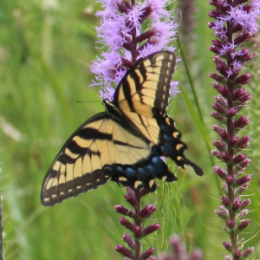
1 | Genus species  FAMILY  Common Name  XX | 2 | Genus species  FAMILY  Common Name  XX | 3 | Genus species  FAMILY  Common Name  XX | 4 | Genus species  FAMILY  Common Name  XX
5 | Genus species  FAMILY  Common Name  XX | 6 | Genus species  FAMILY  Common Name  XX | 7 | Genus species  FAMILY  Common Name  XX | 8 | Genus species  FAMILY  Common Name  XX
9 | Genus species  FAMILY  Common Name  XX | 10 | Genus species  FAMILY  Common Name  XX | 11 | Genus species  FAMILY  Common Name  XX | 12 | Genus species  FAMILY  Common Name  XX
Insert your photo here
300 pixels wide x
300 pixels height
resolution: 72 -250 ppi
the photo must be clear at
100%-150% screen view.
Photo file size must be
150-250kb in size

If applicable, Quality should be 8-10

13 | Genus species  FAMILY  Common Name  XX | 14 | Genus species  FAMILY  Common Name  XX | 15 | Genus species  FAMILY  Common Name  XX | 16 | Genus species  FAMILY  Common Name  XX
17 | Genus species  FAMILY  Common Name  XX | 18 | Genus species  FAMILY  Common Name  XX | 19 | Genus species  FAMILY  Common Name  XX | 20 | Genus species  FAMILY  Common Name  XX
21 | Genus species  FAMILY  Common Name  XX | 22 | Genus species  FAMILY  Common Name  XX | 23 | Genus species  FAMILY  Common Name  XX | 24 | Genus species  FAMILY  Common Name  XX

