Insert your photo here  400 pixels wide x 600 pixels height  Resolution: 72 -250 ppi  the photo must be clear at  100%-150% screen view.  Photo file size must be  150-250kb in size  If applicable, Quality should be 8-10 |  |  |  | 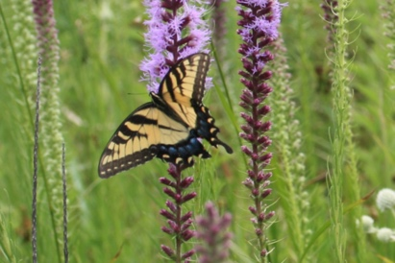
1 |  |  | Genus species  FAMILY  Common Name  XX | 2 | Genus species  FAMILY  Common Name  XX |  |  | 3 |  | Genus species  FAMILY  Common Name  XX |  | 4 |  | Genus species  FAMILY  Common Name  XX
5 | Genus species  FAMILY  Common Name  XX |  |  | 6 |  | Genus species  FAMILY  Common Name  XX |  | 7 | Genus species  FAMILY  Common Name  XX |  |  | 8 | Genus species  FAMILY  Common Name  XX
9 | Genus species  FAMILY  Common Name  XX |  |  | 10 | Genus species  FAMILY  Common Name  XX |  |  | 11 |  |  | Genus species  FAMILY  Common Name  XX | 12 |  | Genus species  FAMILY  Common Name  XX
13 |  | Genus species  FAMILY  Common Name  XX |  | 14 |  |  | Genus species  FAMILY  Common Name  XX | 15 |  |  | Genus species  FAMILY  Common Name  XX | 16 |  | Genus species  FAMILY  Common Name  XX

Insert your photo here
400 pixels wide x 600 pixels height
Resolution: 72 -250 ppi
the photo must be clear at
100%-150% screen view.
Photo file size must be
150-250kb in size
If applicable, Quality should be 8-10

1 |  |  | Genus species  FAMILY  Common Name  XX | 2 | Genus species  FAMILY  Common Name  XX |  |  | 3 |  | Genus species  FAMILY  Common Name  XX |  | 4 |  | Genus species  FAMILY  Common Name  XX
5 | Genus species  FAMILY  Common Name  XX |  |  | 6 |  | Genus species  FAMILY  Common Name  XX |  | 7 | Genus species  FAMILY  Common Name  XX |  |  | 8 | Genus species  FAMILY  Common Name  XX
9 | Genus species  FAMILY  Common Name  XX |  |  | 10 | Genus species  FAMILY  Common Name  XX |  |  | 11 |  |  | Genus species  FAMILY  Common Name  XX | 12 |  | Genus species  FAMILY  Common Name  XX
13 |  | Genus species  FAMILY  Common Name  XX |  | 14 |  |  | Genus species  FAMILY  Common Name  XX | 15 |  |  | Genus species  FAMILY  Common Name  XX | 16 |  | Genus species  FAMILY  Common Name  XX

