Insert your photo here  800 pixels wide x 600 pixels height  resolution: 72 -250 ppi  the photo must be clear at  100%-150% screen view.  Photo file size must be  150-250kb in size  If applicable, Quality should be 8-10 |  | 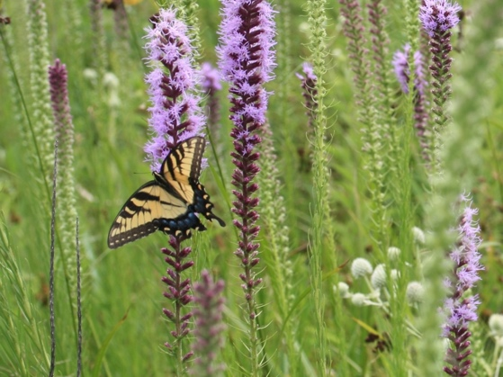
1 | Genus species  FAMILY  Common Name  XX | 2 | Genus species  FAMILY  Common Name  XX | 3 | Genus species  FAMILY  Common Name  XX
4 | Genus species  FAMILY  Common Name  XX | 5 | Genus species  FAMILY  Common Name  XX | 6 | Genus species  FAMILY  Common Name  XX
7 | Genus species  FAMILY  Common Name  XX | 8 | Genus species  FAMILY  Common Name  XX | 9 | Genus species  FAMILY  Common Name  XX

Insert your photo here
800 pixels wide x 600 pixels height
resolution: 72 -250 ppi
the photo must be clear at
100%-150% screen view.
Photo file size must be
150-250kb in size

If applicable, Quality should be 8-10

10 | Genus species  FAMILY  Common Name  XX | 11 | Genus species  FAMILY  Common Name  XX | 12 | Genus species  FAMILY  Common Name  XX
13 | Genus species  FAMILY  Common Name  XX | 14 | Genus species  FAMILY  Common Name  XX | 15 | Genus species  FAMILY  Common Name  XX
16 | Genus species  FAMILY  Common Name  XX | 17 | Genus species  FAMILY  Common Name  XX | 18 | Genus species  FAMILY  Common Name  XX

